[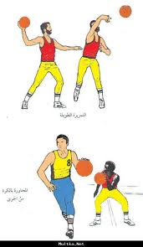](http://www.google.com.om/imgres?imgurl=http://www.hitham.net/up/image/MOF21_6_2007_01_19_06_PM.jpg&imgrefurl=http://hamasatonline.com/vb/showthread.php%3Ft%3D1588&usg=__SaYTNki5zS6jnw56lN-umB5qPp0=&h=864&w=500&sz=147&hl=ar&start=13&zoom=1&tbnid=8KB5suZjBO1qnM:&tbnh=145&tbnw=84&ei=gzw1TqbqLtCxrAfO-oDMCw&prev=/search%3Fq%3D%25D8%25B5%25D9%2588%25D8%25B1%2B%25D9%2585%25D9%2587%25D8%25A7%25D8%25B1%25D8%25A7%25D8%25AA%2B%25D8%25B1%25D9%258A%25D8%25A7%25D8%25B6%25D9%258A%25D8%25A9%26hl%3Dar%26sa%3DG%26rlz%3D1R2RNRN_enOM441%26biw%3D1280%26bih%3D603%26tbm%3Disch%26prmd%3Divns&itbs=1)

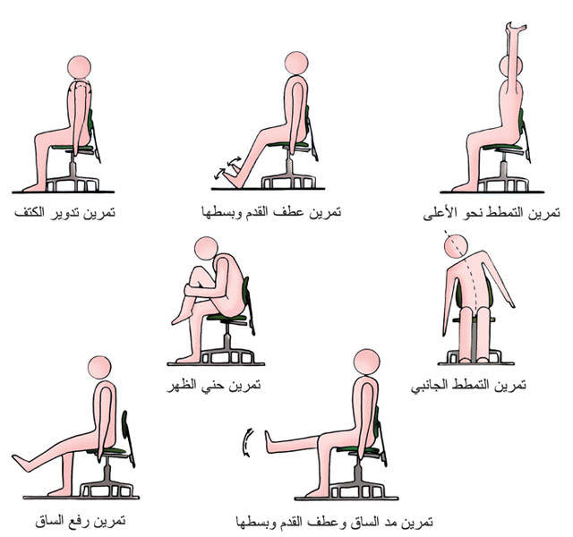

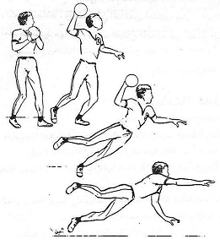

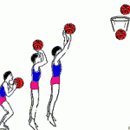

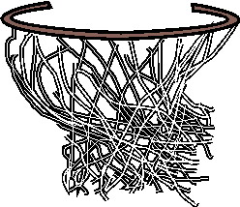

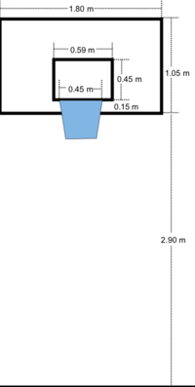

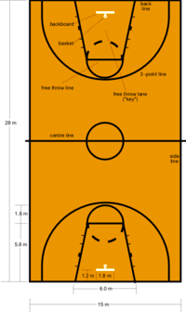

[http://t2.gstatic.com/images?q=tbn:ANd9GcTurxyGky_Owp__VDxYyrs2FUs-lEsqtgMWD1KTGFm5-bz7BJ-t](http://www.google.com.om/imgres?q=%D8%B5%D9%88%D8%B1+%D9%85%D9%87%D8%A7%D8%B1%D8%A7%D8%AA+%D8%B1%D9%8A%D8%A7%D8%B6%D9%8A%D8%A9&hl=ar&sa=G&rlz=1R2RNRN_enOM441&biw=1280&bih=603&tbm=isch&tbnid=GZuaQ8CMD6hN_M:&imgrefurl=http://www.bdnia.com/%253Fp%253D229&docid=4WrSMEYtJTZRQM&w=70&h=45&ei=ljw1Tr2CPIPprAfgzInMCw&zoom=1)

[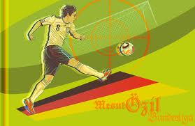](http://www.google.com.om/imgres?q=%D8%B5%D9%88%D8%B1+%D9%85%D9%87%D8%A7%D8%B1%D8%A7%D8%AA+%D8%B1%D9%8A%D8%A7%D8%B6%D9%8A%D8%A9&hl=ar&sa=G&rlz=1R2RNRN_enOM441&biw=1280&bih=603&tbm=isch&tbnid=cUvUZOIxcAc2GM:&imgrefurl=http://7shasha4ever.com/vb/showthread.php%253Fp%253D38474&docid=88mfqCSiEQJYwM&w=1212&h=786&ei=dT41TvzgKcWtrAeotc3LCw&zoom=1)

[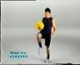](http://www.google.com.om/imgres?q=%D8%B5%D9%88%D8%B1+%D9%85%D9%87%D8%A7%D8%B1%D8%A7%D8%AA+%D8%B1%D9%8A%D8%A7%D8%B6%D9%8A%D8%A9&hl=ar&sa=G&rlz=1R2RNRN_enOM441&biw=1280&bih=603&tbm=isch&tbnid=dAEYTluoIwkV7M:&imgrefurl=http://www.traidnt.net/vb/traidnt1090219/&docid=57IpZfQhElMppM&w=120&h=98&ei=dT41TvzgKcWtrAeotc3LCw&zoom=1)

[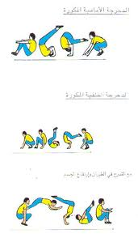](http://www.google.com.om/imgres?q=%D8%B5%D9%88%D8%B1+%D9%85%D9%87%D8%A7%D8%B1%D8%A7%D8%AA+%D8%B1%D9%8A%D8%A7%D8%B6%D9%8A%D8%A9&hl=ar&sa=G&rlz=1R2RNRN_enOM441&biw=1280&bih=603&tbm=isch&tbnid=DkfA1OygabRKhM:&imgrefurl=http://www.sport-8.com/vb/t485.html&docid=hRUqbkXn9KkfNM&w=473&h=811&ei=pz41TsDWBsnJrAeGsYXMCw&zoom=1)

[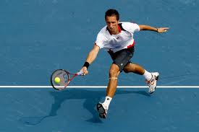](http://www.google.com.om/imgres?q=%D8%B5%D9%88%D8%B1+%D9%85%D9%87%D8%A7%D8%B1%D8%A7%D8%AA+%D8%B1%D9%8A%D8%A7%D8%B6%D9%8A%D8%A9&hl=ar&sa=G&rlz=1R2RNRN_enOM441&biw=1280&bih=603&tbm=isch&tbnid=Bhsf80Vs_RignM:&imgrefurl=http://www.3eoon-alforat.com/vb/t15322.html&docid=QpQY94hbAtTR7M&w=594&h=396&ei=vz41Tu6rConMrQeK06CeCw&zoom=1)

[**وسائل تعليمية لجميع المهارات الرياضية بالشرح المصور**](http://www.bdnia.com/?p=2346)

